ENGINEERING CLINIC ASSIGNMENT 2

1. Considering making toast (toasted bread) as a system, can you map the entities involved, their relationships, and how the emergent function comes about?

NAME : PRAVEEN KUMAR J

YEAR : II –YR

DEPT : MECHANICAL

ROLL NO: 10833

Toast (Toasted bread)

**Toast** is a form of [bread](https://en.wikipedia.org/wiki/Bread) that has been [browned](https://en.wikipedia.org/wiki/Browning_(food_process)) by toasting, that is, exposure to [radiant heat](https://en.wikipedia.org/wiki/Radiant_heat). The browning is the result of a [Maillard reaction](https://en.wikipedia.org/wiki/Maillard_reaction), altering the flavor of the bread and making it firmer so that it is easier to spread toppings on it. Toasting is a common method of making [stale bread](https://en.wikipedia.org/wiki/Staling) more [palatable](https://en.wikipedia.org/wiki/Palatability). Bread is often toasted using a [*toaster*](https://en.wikipedia.org/wiki/Toaster), but [toaster ovens](https://en.wikipedia.org/wiki/Toaster_oven) are also used. [Pre-sliced bread](https://en.wikipedia.org/wiki/Sliced_bread) is most common.

Toast is commonly eaten with [butter](https://en.wikipedia.org/wiki/Butter) or [margarine](https://en.wikipedia.org/wiki/Margarine), and sweet toppings, such as [jam](https://en.wikipedia.org/wiki/Jam) or [jelly](https://en.wikipedia.org/wiki/Fruit_preserve#Jelly). Regionally, savory spreads, such as [peanut butter](https://en.wikipedia.org/wiki/Peanut_butter) or a [yeast extract](https://en.wikipedia.org/wiki/Yeast_extract), may also be popular. Buttered toast may also accompany savory dishes, especially soups or stews, and be topped with heartier ingredients like eggs or [baked beans](https://en.wikipedia.org/wiki/Baked_beans) as a light meal. Toast is a common [breakfast food](https://en.wikipedia.org/wiki/Breakfast_food).

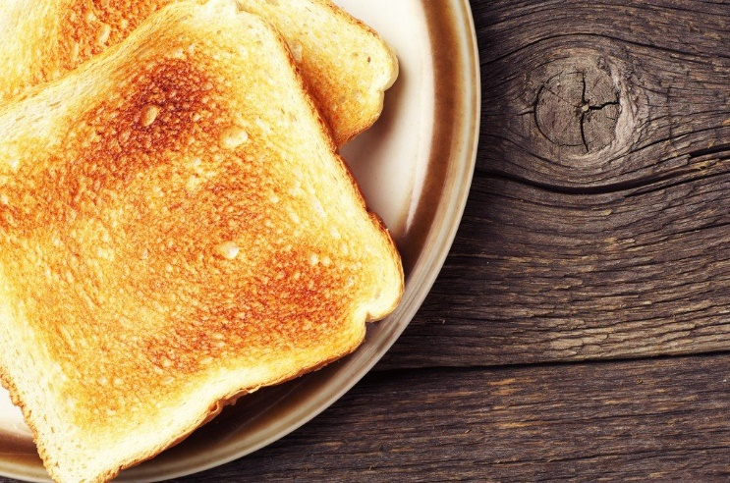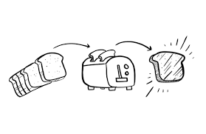

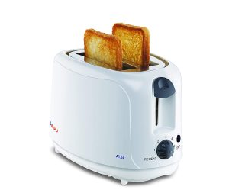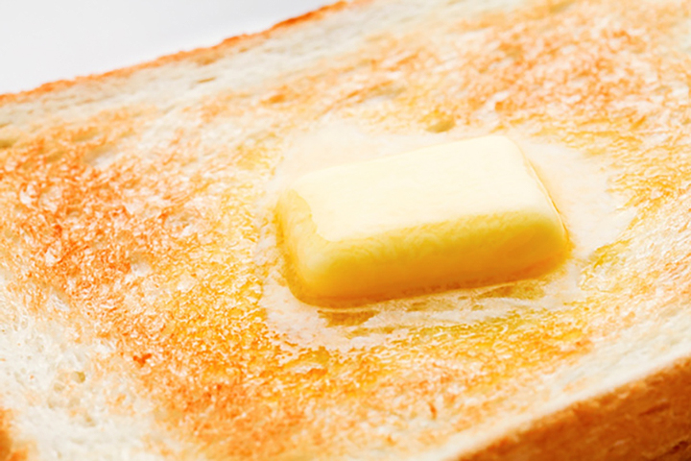

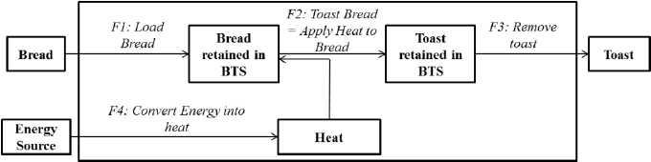

Based on the understanding of the science of toasting, the “working principle” of a BTS can summarized as “reduce bread moisture content and oxidize the surface of the bread”. The BTS engineering design task associated with function F2 is to find a way of delivering the function; in this case this relates to the delivery of heat energy from a given source to the “Bread retained in BTS”. Figure 4 shows an updated SSFD which maps the energy states flow through the BTS system. This shows an “Energy Source” as another input to the system, an intermediate state of “Heat”, and a function F4 to “Convert Energy into Heat”. Given that the SSFD delivered a solution independent analysis, the BTS engineer has the freedom to consider a variety of sources of energy (electrical, gas, chemical, sunlight), and a range of design concepts as ways of converting this energy into heat to achieve the F2- “toast bread” function. Therefore, the attributes of the 2 new states shown in Figure 4 (i.e. “Energy Source” and “Heat”) cannot be fully defined until technology and system design decisions have been made. Function F2 – “Toast Bread” is achieved directly by “Applying Heat to the Bread retained in the BTS”, i.e. heat will change the physical and chemical attributes of bread, transforming it into toast.

 As such, the SSFD in Figure 4 could provide an adequate representation for a range of BTS designs, e.g. a common household electric bread toaster (which holds the bread in a case), a hotel type bread toaster which uses a conveyor belt, or an ecological bread toaster where focused sunlight heat is used to toast the bread. The SSFD diagram in Figure 4 could equally represent a process of toasting bread under a gas grill or over a barbeque, if all the transportation functions on the main flow are performed by the user.